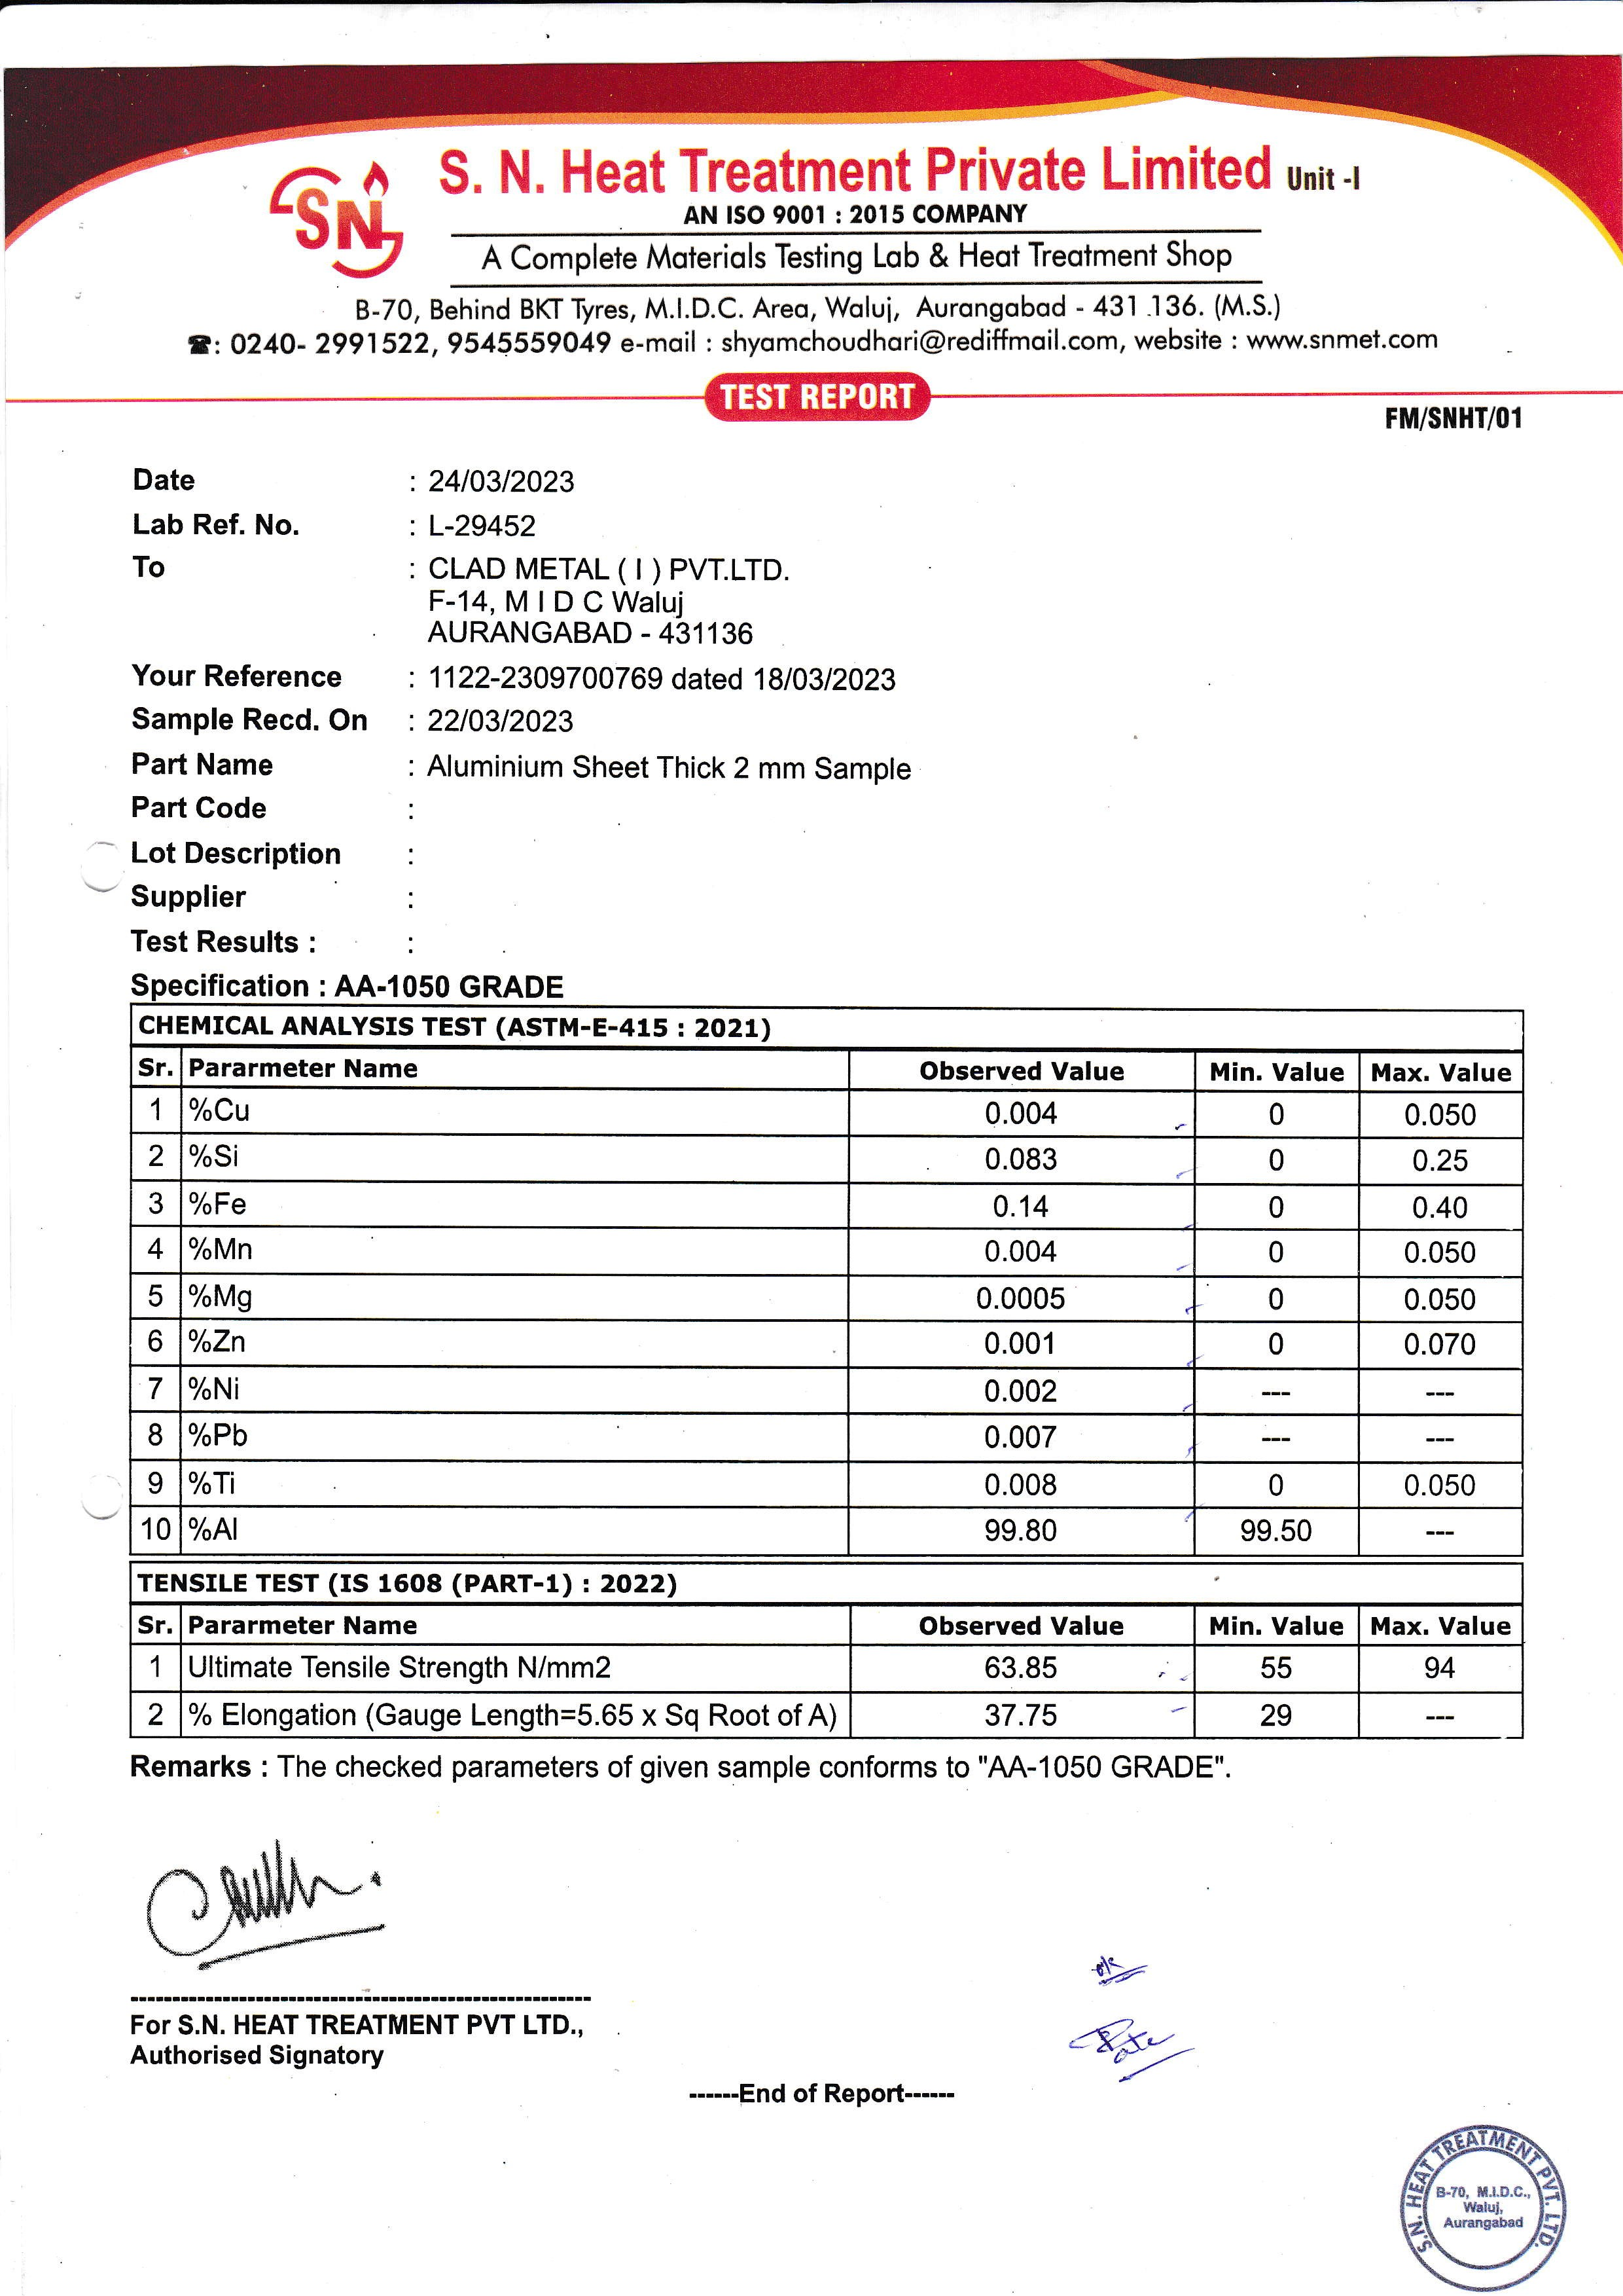



|  |  |  |  |  |
| --- | --- | --- | --- | --- |
| **Date : 16/10/2023** | | | | |
| **Lab Ref.No : L-19118** | | | | |
| **To : CLAD METAL ( I ) PVT .LTD** | | | | |
| **F-14 M I D C Waluj** | | | | |
| **AURANGABAD - 431136** | | | | |
| **Your Reference : 0542 dated 09/10/2023** | | | | |
| **Sample Recd.On : 09/10/2023** | | | | |
| **Part Name : Al Tube Size 6.35 X 1.0 mm Sample** | | | | |
| **Part Code :** | | | | |
| **Lot Description :** | | | | |
| **Supplier :** | | | | |
| **Test Results :** | | | | |
| **Specification : ALUMINIUM -1070-O GRADE** | |  |  |  |
| **CHEMICAL ANALYSIS TEST (ASTM-E-1086)** | | | | |
| **Sr.** | **Parameter Name** | **Observed Value** | **Min.Value** | **Max.Value** |
| **1** | **% Cu** | **0.002** | **0** | **0.030** |
| **2** | **%Si** | **0.047** | **0** | **0.20** |
| **3** | **%Fe** | **0.12** | **0** | **0.25** |
| **4** | **%Mn** | **0.001** | **0** | **0.030** |
| **5** | **%Mg** | **0.001** | **0** | **0.030** |
| **6** | **%Zn** | **0.007** | **0** | **0.030** |
| **7** | **%Al** | **99.82** | **99.70** | **--** |
|  |  |  |  |  |
| **TENSILE TEST (IS 1608)** | | | | |
| **Sr.** | **Parameter Name** | **Observed Value** | **Min.Value** | **Max.Value** |
| **1** | **Ultimate Tensile Strength N/mm2** | **67.24** | **0** | **93.14** |
| **2** | **%Elongation (Gauge Length = 5.65 X Sq of CS Area)** | **47.10** | **25** | **--** |
| **Remarks: The Checked parameters of given sample conforms to ''ALUMINIUM 1070-O GRADE ''.** | | | |  |